

##### USER GUIDE

**WHRSC RECRUITMENT**

##### (Updated: 1/14/2019)

USING THE RECRUITMENT FORM 2

WHEN TO USE THERECRUITMENT FORM 2

INITIATING A RECRUITMENT ACTION 2

AS A STAND-ALONE RECRUITMENT 2

FROM THE CAPITALHR INTERFACE 2

MANAGING RECRUITMENT ACTIONS - BEST PRACTICES (PRE-RECRUITMENT) 6

CREATING MANUAL RECRUITMENT ACTIONS 6

MANAGING RECRUITMENT ACTIONS 7

CLOSING (COMPLETING) A RECRUITMENT ACTION IN THEPRE-RECRUITMENT STAGE 8

CANCELLING RECRUITMENT ACTIONS 8

TRANSACTION INFORMATION TAB 9

PRE-RECRUITMENT INFORMATION TAB: 12

VACANCY ANNOUNCEMENT INFORMATION TAB 17

ATTACHING DOCUMENTS TO ACTIONS 20

DE VACANCY ANNOUNCEMENTS AND WORKING WITHTHE DEU 22

APPLICANT RATING INFORMATION TAB 25

CERTIFICATE INFORMATION TAB 27

COMPLETING THE CERTIFICATE FIELDS 27

CLOSING RECRUITMENT ACTIONS 30

OPTIONS FOR CLOSING RECRUITMENT ACTIONS 31

APPENDIX 1: REMINDER EMAILS 33

POST VACANCY ANNOUNCEMENT EMAIL 33

ISSUE CERTIFICATE (DEU) EMAIL 34

ISSUE CERTIFICATE (DEU) SLA EXCEED EMAIL 35

SEND CERTIFICATE (DEU) TO SELECTINGOFFICIAL EMAIL 36

SEND CERTIFICATE (DEU) TO SELECTING OFFICIAL SLAEXCEED EMAIL 37

SEND CERTIFICATE (MP OR DH) TO SELECTINGOFFICIAL EMAIL 38

CERTIFICATE EXPIRATION EMAIL (HRS) 39

CERTIFICATE EXPIRATION EMAIL (Customer) 40

HIRING DECISION NEEDED EMAIL 41

FEEDBACK REQUESTED EMAIL 42

UNAUDITED CERTIFICATE EMAIL 43

APPENDIX 2: RECRUITMENT WORKFLOW 44

APPENDIX 3: ROUTING OPTIONS 47

# *Using the Recruitment Form*

## When to Use the Recruitment Form

When WHRSC is leading the recruitment effort for Title 5 (non-Senior Executive Service) and announces the vacancy in an OHR Staffing System.

# *Initiating a Recruitment Action*

## As a stand-alone Recruitment

Although the majority of Recruitment actions are auto-generated shortly after a Job Requisition is approved in Capital HR—there may be times when an HR Specialist needs to manually initiate a Recruitment action. In those cases only, the HR Specialist will select Recruitment from the Process Initiation BizCove on the Work Area Page:



## From the Capital HR interface

Shortly after a Capital HR Job Requisition is approved, an action is automatically generated and can be found in the **Unassigned Staffing Processes** BizCove. The action is then held in the unassigned staffing area until a WHRSC staff member retrieves it and assigns it as either a Recruitment or an Appointment.



Assigning these actions and beginning work on them in a timely manner is critical. For this reason, a series of reminder emails are sent (on business days only) when an action has not been assigned to an HR Specialist:

**On the 3rd business day** – email to all Team Leaders in the branch

**On the 5th business day** – email to Branch Chief

**On the 7th business day** – email to Deputy Director that is assigned to the branch

To assign the action, the WHRSC customer will click on the “Open” button



### Recruitment or Appointment

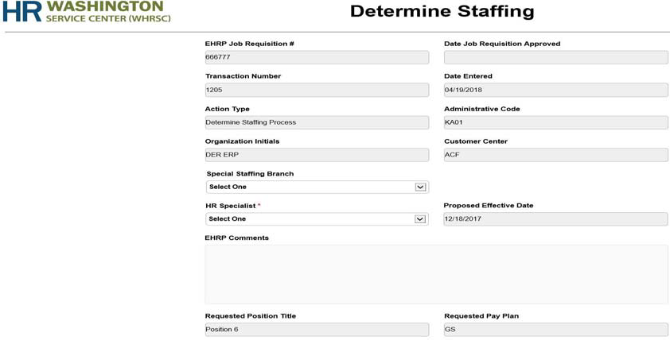When the WHRSC staff member opens the action, the Determine Staffing form displays information that was sent from Capital HR.

The WHRSC staff member reviews this information and determines whether the action is a Recruitment or an Appointment. This step is

necessary because the WHRSC customer may enter Capital HR Job Requisitions for Recruitments but may also enter them for Appointments where recruitment is not necessary (Shared Certificate selections, Committee Members, Special Experts, certain non-competitive appointments, etc.). Whether the Capital HR Job Requisition is used in this manner will vary from customer to customer.

All of the fields on the Determine Staffing page contain information that was entered by the staff member and cannot be edited at this junction. These fields can be edited after an Appointment or Recruitment action is created. Blank fields indicate that the WHRSC customer did not enter the information into Capital H. R

Any comments the WHRSC customer entered into the Capital HR Job Requisition are listed in the Cap HR Comments field; any attachments to the Capital HR Job Requisition are also contained in the action.

#### Steps for assigning a Determine Staffing action to an HR Specialist:

The WHRSC customer indicates whether the Special Staffing Branch (SSB) will handle the action or not.

The WHRSC customer assigns the action to the appropriate HR Specialist by selecting their name from the HR specialist drop down menu.

If the action is a Recruitment, the WHRSC customer clicks the Recruitment button at the bottom of the Determine Staffing screen.

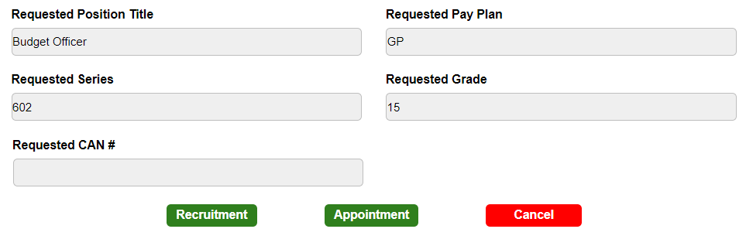

If it is determined that the action is an Appointment, the WHRSC customer

clicks the Appointment button at the bottom of the Determine Staffing screen. For more information on how to use the Appointment workflow, please reference the User Guide – Appointment. If the action was initiated in error, you can cancel the action. You may re-use the Capital HR Job Requisition # if you cancel an action.

The Recruitment action is sent to the worklist of the assigned WHRSC HR Specialist.

Upon receipt of the Recruitment action, the WHRSC HR Specialist reviews or completes the information on the Transaction Information and Pre-Recruitment Information tabs.

**Tip:** Please ensure that the remarks entered by the WHRSC customer do not contain Personally Identifiable Information (PII). If you find PII, please contact the support team as soon as possible.

# Managing Recruitment Actions - Best Practices (Pre- Recruitment)

### Creating Manual Recruitment Actions

Although the majority of Recruitment actions are auto-generated

shortly after a Capital HR Job Requisition is approved, there may be times when a WHRSC HR Specialist needs to initiate a Recruitment action manually. To promote consistency and to track the length of time an action spends in the ‘Pre- Recruitment’ stage (i.e., the time between the ‘Date Entered’ and the ‘Date Complete Package Received’) accurately, HR Specialists should adhere to the following guidance:

##### Before creating a Recruitment action, the WHRSC HR Specialist should request that the WHRSC customer approve the Capital HR Job Requisition

The WHRSC HR Specialist should contact the WHRSC customer (or Administrative Officer) and ask that they approve of the Capital HR Job Requisition. If after multiple attempts and the WHRSC customer has not approved the Capital HR Job Requisition, then the WHRSC HR Specialist should create a manual Recruitment action.

##### Before performing any “substantial” work on a vacancy announcement, the WHRSC HR Specialist should create the associate Recruitment action, if the WHRSC customer has not approved the Capital HR Job Requisition.

For the purposes of this guidance, “substantial” means any work including, but not limited to any effort associated with assessment/job analysis creation or modification, vacancy announcement development, and other similar functions. Substantial does NOT mean casual conversations about a vacant position, sharing certificates, sharing position descriptions, and other similar functions.

If a Capital HR Job Requisition is initiated after a Recruitment action has already been entered manually, the WHRSC HR Specialist should cancel the subsequent action that was generated by the interface.

### Managing Recruitment Actions

To promote consistency, WHRSC HR Specialists should adhere to the following guidance:

##### WHRSC HR Specialists should update the Action Status fields and keep comments up-to-date

The WHRSC HR Specialist should be especially mindful of these fields during the Pre-Recruitment phase of the recruitment. Keeping this information accurate provides WHRSC Leadership (and WHRSC customers) with a ‘quick look’ at the action.

#### Recruitment Action Status Page

To aid in updating the Action Status fields daily, there is a Recruitment Action Status page that must be accessed every 24 hours to update the status and add comments for each Recruitment Action with a CapHR Request ID.

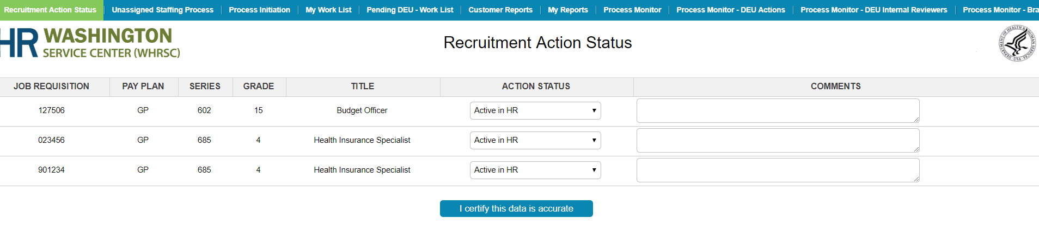

### Closing (Completing) a Recruitment Action in the Pre- Recruitment Stage

There may be times when a WHRSC HR Specialist has to close a recruitment action during the Pre-Recruitment Stage.

**Note:** Closed actions are removed from the pre- recruitment reminder emails. The WHRSC HR Specialist has three options to close a recruitment action during the Pre-Recruitment Stage. Please review the **Closing Recruitment Actions** section of this guide for more information on closing recruitment actions.

**Action Disapproved – Close Action:** Select this option when the WHRSC, Office of Human Resources, or other office/organization disapproves or requests the stoppage of the recruitment action, for any reason. This will close (not cancel) the action and send it to Archives.

**Position Not Filled – Close Action:** Select this option when the WHRSC customer does not wish to fill the position or the position was not filled. This will close (not cancel the action and send it to the Archives.

**No response– Close Action:** Select this option when you (the WHRSC HR Specialist) have received no communication or follow-up on the recruitment action for 90 consecutive days during the pre-recruitment phase of the action. Please consult your Team Leader or Branch Chief before using this option. This will close (not cancel) the action and send it to the Archives.

### Cancelling Recruitment Actions

There may be times when a WHRSC HR Specialist has to cancel a recruitment action Note: Cancelled actions do not appear on any reports (including the workload report), and they are removed from all reminder emails. If a WHRSC HR Specialist performs a substantial amount of work on an action, they should consider completing the action using one of the options in the **Closing Recruitment Actions** section of this guide. Only cancel a recruitment action if the WHRSC HR Specialist creates a manual recruitment action and the WHRSC customer subsequently approves a Capital HR Job Requisition (WHRSC HR Specialist must cancel the recruitment action created through the Capital HR Interface) **OR** if the recruitment action was entered in error.

## Transaction Information Tab

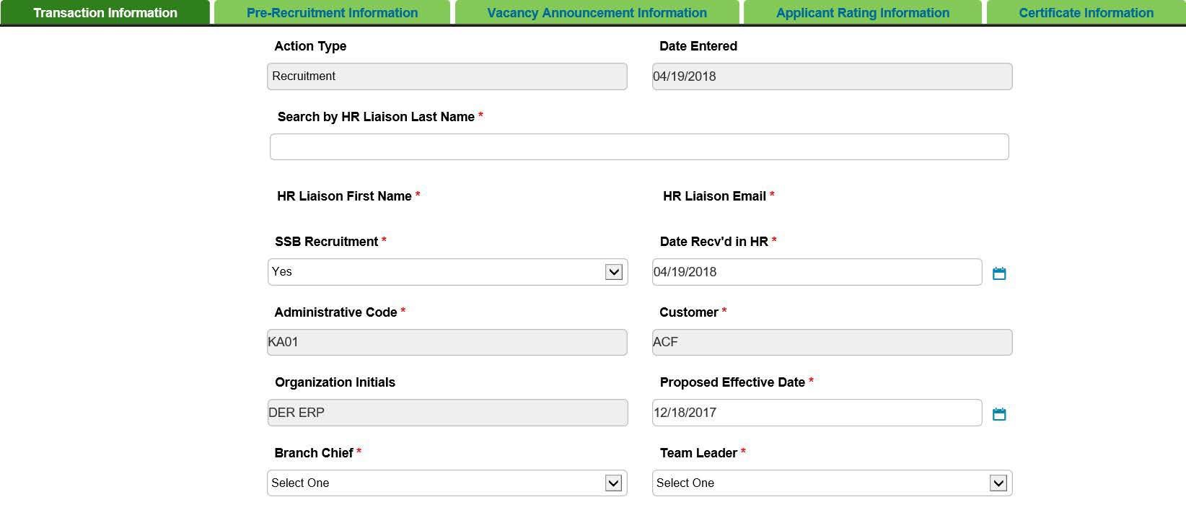

**Note:** DO NOT click the back button on your browser to return to prior tabs.

**Date Entered:** Automatically assigned when the recruitment action is created, and is un- editable.

**Date Recv'd in HR:** Is automatically assigned (same date as when the action was created). This field is editable. This field represents the date that the initial request for a recruitment was received by the WHRSC HR Specialist.

**HR Liaison First Name, Last Name, Email address:** The HR Liaison's First Name and Email Address will be auto-populated by typing/ locating the last name for that HR Liaison.

**SSB:** Select "Yes" if this is a Special Staffing Branch. Otherwise, select "No."

**Administrative Code, Customer Center, Organization Initials:**

Enter the Admin Code associated with the recruitment. For Capital HR- initiated recruitment actions, this field will be auto-populated with the information from Capital HR.

**Proposed Effective Date:** Enter the estimated effective date of the first selection from this recruitment action.

**Upon receipt:** Set the date to when you forecast the first appointee's effective date.

**Upon Cert Issuance:** Enter the date when all of the certificates will expire. This keeps the action active so that it will be captured on the Vacancy Announcement and Certificate Report and Status Report.

**Branch Chief, Team Leader, Recruitment Program Manager (HR Senior Advisor). HR Specialist, HR Assistant, and Final Authorizer:** Select the appropriate participants.

**Is the package complete:** This will default to “No.” When the recruitment package is complete, this field should be changed to “Yes.”

**Date Complete Package Received:** Enter the date when all necessary documents have been received from the program to begin the pre-recruitment process.

### Comments and Action Status

Comments and Action Status are some of the key fields that could be used for reports for HR staff and WHRSC customers. It is important that these fields are current and accurate. Entries in the Comments section should include a timeline of the action’s progression. They should be listed in reverse chronological order with the most recent entry at the top of the comments field, and they should be updated at least weekly.

##### Best Practices for Comments:

**Be Brief—**The Comments field allows 5000 characters, which includes spaces. List only what is necessary to avoid causing the action’s entry in the reports.

**Be diplomatic** – Your comments should not include sensitive information about employees. Be mindful of the fact that our WHRSC customers view these comments through reports and be careful not to give the appearance of assigning “blame” if an action is taking longer than expected.

**Be careful**—Do not add any information related to name requests or other information that may give the appearance of pre-selection.

**Be timely** – Your comments should reflect the most recent status of the action and always check your spelling and grammar.

## Pre-Recruitment Information Tab:

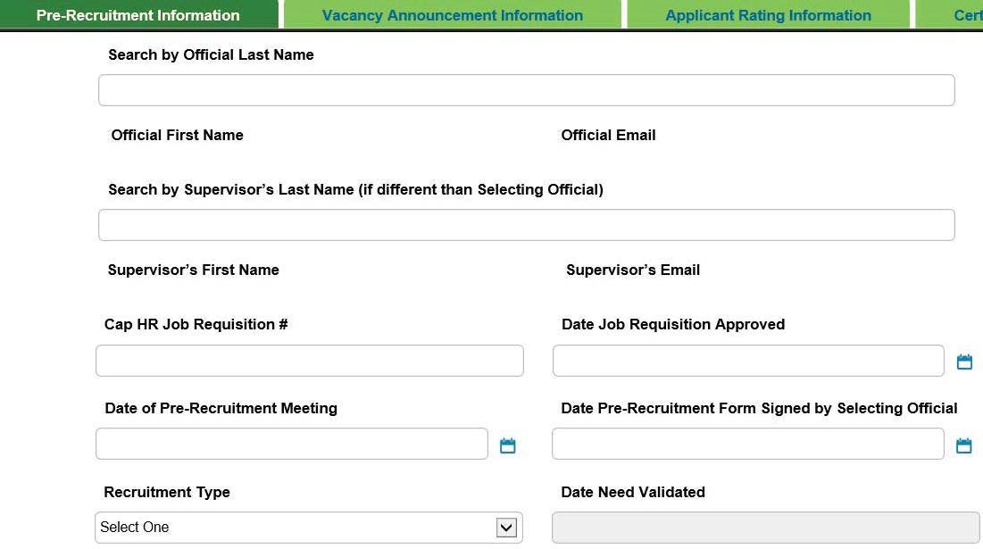The Pre-Recruitment Information tab is meant to collect data related to the WHRSC’s recruitment request and the pre-recruitment consulting during the Pre- Recruitment Stage that is performed by OHR. All of the fields on the Pre-Recruitment Information tab are required before sending an action to the Delegated Examining Unit (DEU), if applicable, for vacancy approval.

**Selecting Official's First Name, Last Name, Email address:** The Selecting Official's First Name and Email Address will be auto-populated by typing/ locating the last name for that official. Names are ordered by Last Name then First Name.

**Supervisor's First Name, Last Name, Email address:** These fields are only needed in cases where the position's supervisor is different from the Selecting Official. The Supervisor's First Name and Email Address will be auto-populated by typing/ locating the last name for that supervisor.

**Cap HR Job Requisition Number:** Enter the Capital HR Job Requisition number. For Capital HR-initiated Recruitment actions, this field will be auto-populated.

**Note:** You can reuse a requisition number multiple times if needed.

**Date Recruitment Authorized:** Enter the date that the Recruitment was authorized.

**Date of Pre-Recruitment Meeting:** Enter the date of the Pre-Recruitment Meeting with the WHRSC customer, if held.

**Date Pre-Recruitment Form Signed by Selecting Official:** Enter the date the Pre- Recruitment Worksheet was signed by the Selecting Official and Administrative Officer.

**Recruitment Type:** In most cases, select Title 5. Title 38 is also available.

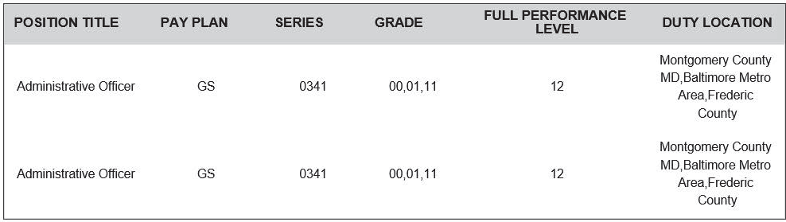

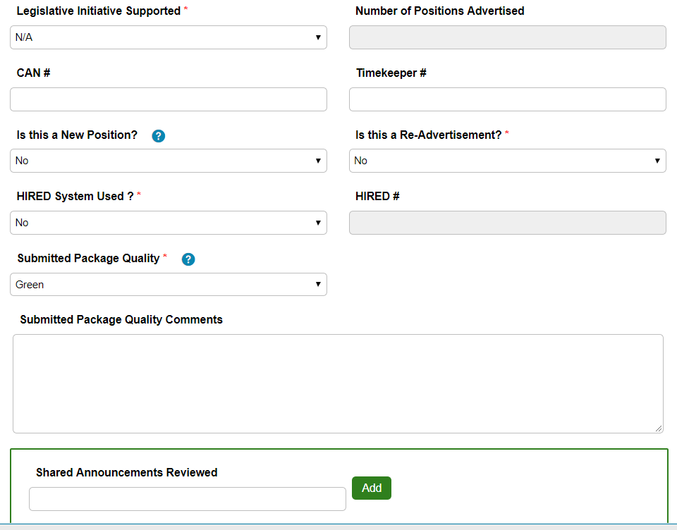

**Legislative Initiative Supported:** Indicate whether the position will be supporting one of the following Legislative Initiatives: The American Recovery and Reinvestment Act

{ARRA}, Road map, Stem Cell, or Other research. If the position will not be supporting a Legislative Initiative, leave the field as 'N/A'.

**Number of Positions Advertised:** This will be populated from the USA Staffing based on the Request Number.

**CAN Number:** This will be populated through CAP HR.

**Timekeeper Number:** Enter the alpha-numeric value of the position's Timekeeper.

**Is this a New Position:** Indicate whether this is a new position or not. A "New

Position" is defined a as a full-time equivalent designation with a brand new

position description or classification. A minor modification to the position description is not a New Position.

**Is this a Re-Advertisement:** Indicate whether this is a re-advertisement of a previously announced position. Re-advertisements are usually within 60 days of the previously announced position's closing date. Please consult your Team Leader and Branch Chief before re-advertising a position.

**HIRED System Used:** Indicate whether a HIRED position description was used. "Used" is defined as using an HHS HIRED or the Evaluation Statement as the basis for the position description of the advertised position.

**HIRED Number:** If an HIRED Number PD was used, enter the HIRED Number.

**Submitted Package Quality:** Select "Green" if no changes are required, Select "Yellow" if HR specialist made minor changes without returning to customer, Select "Red" if HR specialist had to return package to customer for substantial changes.

**Submitted Package Quality Comments:** Enter the required comments.

**Shared Announcements Reviewed:** If the recruitment had more than one announcements reviewed, enter all announcement numbers reviewed. Do not enter duplicate numbers.

**Related WHRSC Classification Number:** Enter the position description (PD) number.

**Transitional Recruitment:** If this is a transitional recruitment {recruiting while the position is still encumbered for training purposes-often called Dual Incumbency}, select Yes. Otherwise, select No.

**Other Recruitment Considerations:** Indicate if alternative methods were considered before posting a vacancy announcement. Indicate if applicants were reviewed by the Selecting Official through a shared certificate, the use of a SSB recruitment was available and proposed to the Selecting Official, or if Other Considerations were pursued. Other Considerations are any other alternative methods to filling a position without the posting of a vacancy announcement such as the review of non- competitive applications {Schedule A, VRA eligibles, Reemployed Annuitants, Direct Hire, etc.}. If no considerations were used before recruiting, select N/A.

**Clearance Level Required for Position:** This will be populated from the USA Staffing system based on the Request Number.

**Paid Ad:** Indicate whether a paid advertisement will be used for this recruitment. Please consult your Branch Chief before using a paid advertisement.

**Date Paid Ad Approved:** If a paid advertisement will be used for this recruitment, enter the date it was approved. This is usually the date that your Branch Chief approved the advertisement.

**Will Relocation Expenses Be Paid:** Indicate whether the WHRSC customer is willing to pay relocation expenses for a selected candidate.

**Date Priority Placement Program (PPP) Checked:** Select a date from the form Calendar.

**Date 10-Pt File Checked:** This field is editable by DEU only.

**PPP Cleared:** Select "Yes" or "No".

**Incentives Offered:** Select which incentive(s) the WHRSC customer, if any, will offer to a selected candidate.

**Additional Recruitment Channels:** Select all that apply, if any.

**Pre-Recruitment Comments:** This field will be populated with any comments the WHRSC customer entered in the Capital HR job requisition. The field is editable if you need to add or edit any comments.

###### Communication Point

After the program area initially submits a recruitment request package, the WHRSC HR Specialist has the option to select "Send Pkg Rec'd Email" from the routing menu. This will send an automatic email notice to the HR Liaison, Selection Official, Supervisor, and the HR Specialist that the Recruitment action has been received in HR.

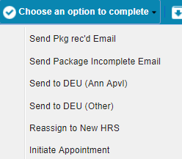

**Tip:** The steps that follow occur over the life of the recruitment action. It will be necessary to continually save and retrieve the action to update the information as the case progresses. It is critical that the Action Status and Comments be updated as the case continues.

## Vacancy Announcement Information Tab

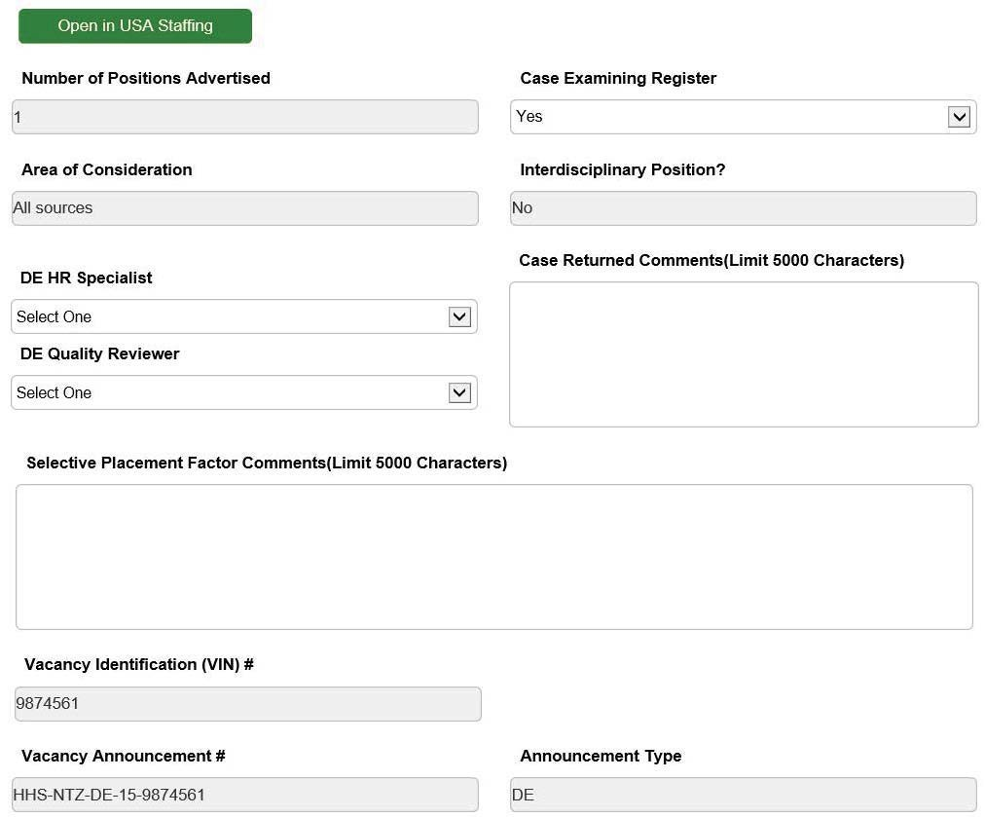The Vacancy Announcement Information tab is meant to collect data related to the announcement(s) of the position(s).

**Open in USA Staffing:** Users can review the announcements in USA Staffing related to selected Request Number by accessing this button.

**Numbers of Positions Advertised:** Use this field to review number of positions advertised, the data is pre-populated from the USA Staffing system.

**Case Examining Register:** Please indicate if the Recruitment is a Case Examining Register. The default option is 'No.'

A Case Examining Register is a recruitment method using the same guidelines, principles, and procedures as a traditional Case Examining vacancy; however, a List of Eligibles is furnished upon the selecting official’s request rather than at pre-determined dates. Lists are issued at the time of request, starting from when the vacancy opens through the expiration date of the register.

**Area of Consideration (AOC):** Use this field to review the Area of Consideration from the USA Staffing system. If area of consideration is "All Sources" or "DE only" the "DE HR Specialist" and "DE Quality Reviewer" will be displayed. If area of consideration is any other source; only "Quality Reviewer" will be displayed.

**Interdisciplinary Position?** Use this field to review the Interdisciplinary Position, the data is pre-populated from the USA Staffing system according to Request Number

**DE HR Specialist:** Select the appropriate DE HR Specialist

**Qualifications Quality Reviewer:** Select the appropriate Qualifications Quality Reviewer

**Vacancy Announcement Review Notes (for DEU Only):** Enter any Vacancy Announcement Review notes as required

**Selective Placement Factor Comments (for DEU Only):** Enter the comments related to Selective Placement Factor

**Vacancy Identification (VIN) Number:** Use this field to review the VIN Number, the data comes from the USA Staffing system.

**Vacancy Announcement Number:** Use this field to review the Vacancy Announcement Number, the data is pre-populated from the USA Staffing system according to Request Number.

**Announcement Type:** This is populated from the USA Staffing system.

**Tip:** Ensure the vacancy announcement number, vacancy identification number (VIN), and announcement type are correct before sending the action to the DEU for approval, and before you enter data on the Applicant Rating Information and Certificate Information tabs.

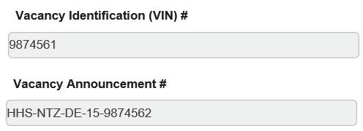

**Date Announcement Sent to DEU:** This date field is auto-populated when the routing option ‘Send to DEU (Ann Apvl)’ is used to send the Announcement to DEU

**Date Announcement Approved by DEU (for DEU Only):** Enter the date when the Announcement was approved by DEU

**Announcement Quality:** Select the quality (Green, Yellow or Red) of the Announcement.

**Date Announcement Posted:** Use this field to review the Date Announcement Posted, the data is pre-populated from the USA Staffing system according to Request Number.

**Date Announcement Opened:** Use this field to review the Date Announcement Opened, the data is pre-populated from the USA Staffing system.

**Date Announcement Closed:** Use this field to review the Date Announcement Closed, the data is pre-populated from the USA Staffing system.

**Date Announcement Cancelled:** Use this field to review to review the Date Announcement Cancelled, the data is pre-populated from the USA Staffing system.

**Open Continuous Announcement:** Select whether this is an Open Continuous Announcement or not.

**Direct Hire:** Select Yes or No.

### Attaching Documents to Actions

It is a best practice to attach the recruitment case file and any other sensitive, documents to the action.

##### Examples of Appropriate Documents to Attach to Recruitment Actions

Fax Cover Sheet

Vacancy Case

File Checklist

Pre Recruitment Worksheet

SF-39

Capital HR Job Requisition or SF-52 Assessment Approval (for unique positions) Job Analysis

USA Staffing Assessment tool for modifications Selective Factor Justification (if applicable)

OF-8(s) and Position Descriptions SME documentation (if applicable)

Term or Temporary Justification (if applicable)

Any other documents that do not contain Personally Indefinable Information (PII)

**Tip**: If a document contains PII and you need to attach it to the action, please scrub the sensitive information from the document and re-scan it. You can also use the Redaction feature in Adobe Professional, if you have the software.

##### Communication Point

When the vacancy is ready for the WHRSC customer review/approval, the Branch HRS has the option to select "Send Rev/App Email" to send an email to the AO and/ or Selecting Official stating that the vacancy announcement, assessment questions, etc. are ready for their review.

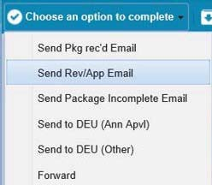

These documents can be attached to the action and will be sent along with the email.

### DE Vacancy Announcements and Working with the DEU

The Delegated Examining Unit is responsible for approving DE vacancy announcements, issuing DE certificates, auditing DE recruitment cases, and approving DE selections. The Branch HRS must send the recruitment action to the DEU for vacancy approval, certificate issuance, and final audit.

#### Routing Actions to the DEU for Vacancy Approval

The WHRSC HRS reviews the information related to the vacancy announcement(s) on the Vacancy Announcement Information tab. When the ‘Area of Consideration’ is ‘All Sources’ or ‘DE Only’, the Branch HRS is required to select a DE HR Specialist and a DE Quality Reviewer prior to send the action to the DEU for vacancy approval.

##### The following fields are required before sending the recruitment action to the DEU for vacancy approval:

All of the fields on the Transaction Information tab (Except: Date Complete Package Received) All of the fields on the Pre-Recruitment Information tab All of the fields on the Vacancy Announcement Information tab.

##### Vacancy Announcement Information tab

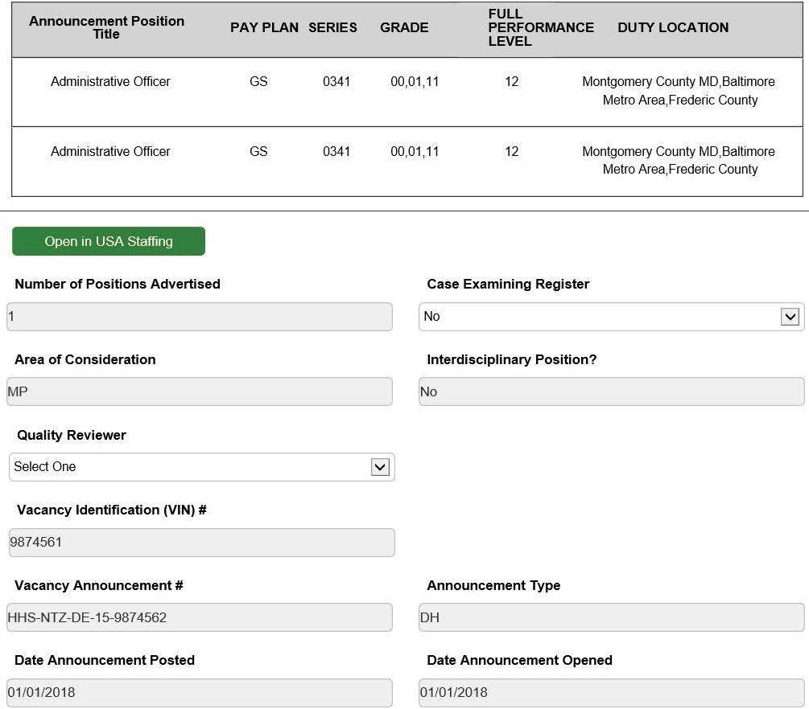

Only members of the DEU can edit the “Case Returned Comments” and “Selective Placement Factor Comments" fields.

**Tip:** When the Branch HRS has prepared the vacancy announcement(s) and is ready for the DEU to review and approve, he or she selects “Send to DEU (Ann Appvl)” to send the action to the DEU. This must be done in real-time as this action sets the ‘Date Sent to DEU’ field.

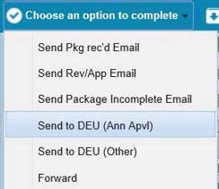

An email is sent to the Branch HRS, with a cc to the DE Quality Reviewer. The action is then sent to the DEU worklist.

#### DEU Vacancy Announcement Review/Approval

***Upon receipt of the recruitment action, the DE Quality Reviewer has the following options:***

##### Approve the announcement

In this case, the Branch HRS will receive an email stating that the announcement has been approved by the DE Quality Reviewer and is ready to be posted. The system will return the action to the Branch HRS with the ‘Date Announcement Approved by DEU’ field completed.

##### Return the Action to the Branch

In this case, the Branch HRS will receive an email stating that the action is being returned to them and giving them the reason (for example, it was sent in error, it needs extensive revision before it can be approved, etc.). The system will return the action back to the Branch HRS.

##### Mark the action as ‘Pending Selective Placement Factor Review’

In this case, the Branch HRS will receive an email stating that the action is being placed in a pending status because the announcement contains a Selective Placement Factor and needs to be reviewed by the DEU Chief. The action will remain with the DEU. An additional email will be sent to the Branch HRS with the DEU Chief’s decision. The action will be returned to the Branch HRS when the vacancy, as a whole, is approved.

## Applicant Rating Information Tab

The Applicant Rating Information tab is meant to collect data related to the vacancy announcement(s)’ applicants. Some fields are reserved for the DEU when the announcement type is DE. These fields will be ‘grayed out’ to non-DEU staff.

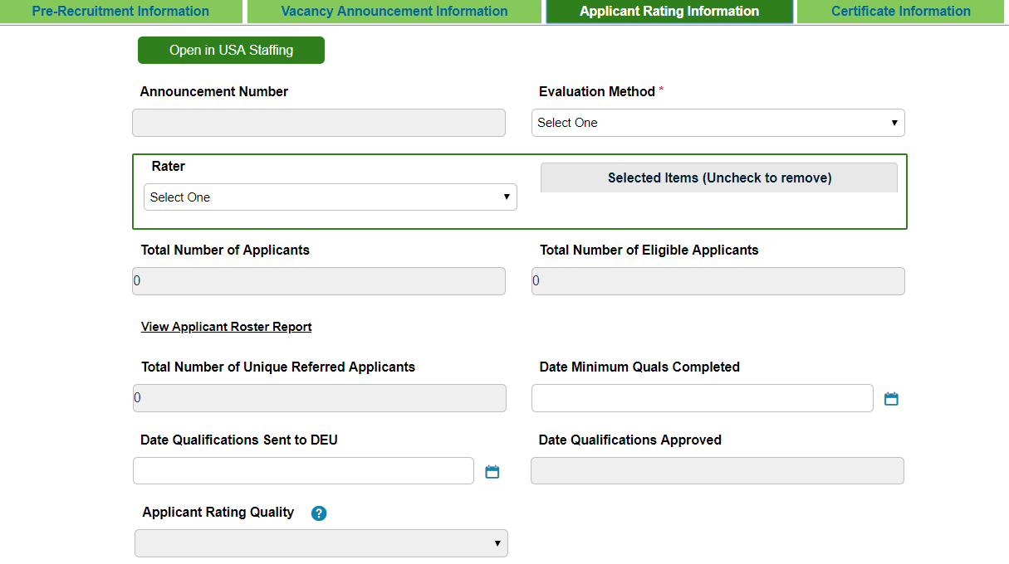

**Announcement Number:** Use this field to review the Announcement Number, the data is pre- populated according to Request Number.

##### Evaluation Method:

**Basic Quals:** Select this option when the applicant pool is only being rated for basic qualifications (e.g., Direct Hire or Title 42 announcements).

**Traditional:** Select this option for announcement covered by the

**WHRSC Merit Promotion Plan** where the applicant pool will not be rated using Category Rating Procedures.

**Category Rating:** Select this option for any announcement where the applicant pool will be placed into categories as defined in the HHS Category Rating Policy.

**Phasing:** Select this option for announcements where the rating process is carried out through a series of stages ( e.g., Structured and Rated Interviews).

**Rater:** Select HRS (Branch HR Specialist, DEU (DEU HR Specialists, QRB (Qualifications Review Board and/or SME (Subject Matter Expert.

**Total Number of Applicants:** Use this field to review the Total Number of applicants, the data is pre-populated from the USA Staffing system according to Request Number.

**Total Number of Eligible Applicants**: Use this field to review the Total Number of eligible applicants, the data is pre-populated from the USA Staffing system according to Request Number.

**Total Number of Unique Referred Applicants**: Use this field to review the Total Number of unique referred applicants, the data is pre-populated from the USA Staffing system according to Request Number.

**Date Minimum Quals Completed**: Enter the date that the review of all applicants for minimum qualifications was completed.

**Date Qualifications Sent to DEU:** Enter the date Qualifications were sent to DEU

**Date Qualifications Approved (for DEU Only):** Enter the date qualifications were approved by DEU

**Applicant Rating Quality (for DEU Only):** Enter Green, Yellow or Red for the Applicant Rating Quality

**Quality Review Notes (for DEU Only):** Enter the Quality Review Notes if any

**Date Applicants Notified of Qual/Elig Status:** Use this field to review the date applicants notified of qual/elig status, the data is pre-populated from the USA Staffing system according to Request Number. This is the date for USA Staffing announcements that the Referral Letter, Notification Letter, Notice of Results (NOR), Cancellation Letter was sent.

**Date Applicants Notified of Referral Status:** Use this field to review the date applicants notified of referral, the data is pre-populated according to Request Number. This is the date for USA Staffing announcements that the Referral Letter, Notification Letter, Notice of Results (NOR), or Cancellation Letter was sent.

Specialist should use the Applicant Notifications Report to gather this information.

**Date Apps to SME/QRB**: Enter the date apps sent to SME/QRB.

**Date App Evaluation Completed by SME/QRB:** Enter the date app evaluation completed by SME/ QRB.

## Certificate Information Tab

The Certificate Information tab is meant to collect data related to the certificates issued for the vacancy announcement(s).

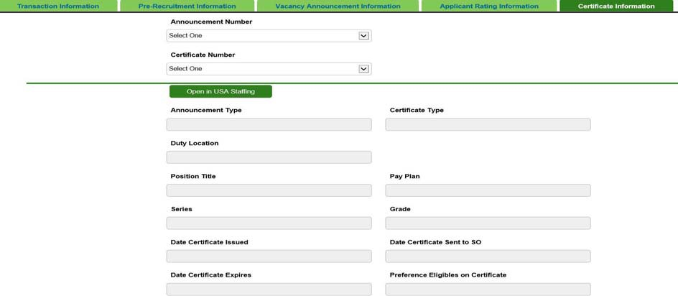

### Completing the Certificate fields

#### Who should complete the fields on the Certificate Information Tab

**Non-DEU Certs:** indicates that the Branch HR Specialist should complete this field for non-DEU certificates only.

**DEU:** indicates that the field is reserved for members of the DEU when the certificate is 'DE' or 'NC- DE.'

**Branch HRS:** indicates that the Branch HRS, no matter the certificate type should always complete the field.

**Announcement Number:** (Non-DEU Certs) Select an announcement number from the drop down menu.

**Certificate Number:** (Non-DEU Certs) Select a certificate number from the drop down menu.

**Announcement Type:** Use this field to review the announcement type, the data is pre-populated from the USA Staffing system according to Request Number.

**Certificate Type:** (Non-DEU Certs) Use this field to review the certificate type, the data is pre-populated from the USA Staffing system according to Request Number.

**Duty Location:** (Non-DEU Certs) Use this field to review the duty location, the data is pre- populated from the USA Staffing system according to Request Number.

**Position Title:** (Non-DEU Certs) Use this field to review the position title, the data is pre- populated from the USA Staffing system according to Request Number.

**Pay Plan:** (Non-DEU Certs) Use this field to review the pay plan, the data is pre-populated from the USA Staffing system according to Request Number.

**Series:** (Non-DEU Certs) Use this field to review the series, the data is pre-populated from the USA Staffing system according to Request Number.

**Grade:** (Non-DEU Certs) Use this field to review the grade, the data is pre-populated from the USA Staffing system according to Request Number.

**Date Certificate Issued:** (Non-DEU Certs) Use this field to review the date certificate issued the data is pre-populated from the USA Staffing system according to Request Number.

**Date Certificate Sent to SO:** (Branch HRS) Use this field to review the date certificate Sent To SO, the data is pre-populated from the USA Staffing system according to Request Number.

**Date Certificate Expires:** (Non-DEU Certs) Use this field to review the date certificate expires, the data is pre-populated from the USA Staffing system according to Request Number.

**Preference Eligibles on Certificate:** (Non-DEU Certs) Use this field to review preference eligibles on certificate, the data is pre-populated from the USA Staffing system according to Request Number.

**Certificate Extended:** Select "Yes" or "No"

**New Cert Expiration Date:** (Branch HRS) Use this field to review the new cert expiration date, the data is pre-populated from the USA Staffing system according to Request Number.

**Selections Made?** (Branch HRS) Use this field to review whether selections were made, the data is pre-populated from the USA Staffing system according to Request Number.

**Action Taken**: (Branch HRS) Use this field to review whether actions were taken, the data is pre- populated from the USA Staffing system according to Request Number.

**Date of Hiring Decision:** (Branch HRS) Use this field to review the date of hiring decision, the data is pre-populated from the USA Staffing system according to Request Number.

**Date Hiring Decision Rec’d in HR:** (Branch HRS) Use this field to review the date hiring decision received in HR, the data is pre-populated from the USA Staffing system according to Request Number.

**Date Final Applicant Statuses Set:** (Branch HRS) Use this field to review the date final applicant statuses set, the data is pre-populated from the USA Staffing system according to Request Number.

**Date Audit Completed:** Use this field to review the date final audit was completed, the data is pre- populated from the USA Staffing system according to Request Number.

**Date Internal Review Completed:** Select using the calendar.

**Cert Cancelled:** Select "Yes" or "No"

**Cert Returned Unused Reason:** Select an option from the drop down menu.

**Date Cert Returned to DEU for Final Closeout Audit:** Select using the calendar.

**Cert Returned Unused Reason (Other):** Use this field to review the reason the cert was returned unused, the data is pre-populated from the USA Staffing system according to Request Number.

##### Closing Recruitment Actions

The Initiating HR Specialist (person noted on the Recruitment action) is responsible for gathering all applicable information from any shared certificate and additional selection activity, and updating the recruitment action.

The Initiating HR Specialist will complete their recruitment action or send the action to the DEU for final audit when all of the certificates have expired, all Hiring Decisions (i.e., selections or non- selections) have been returned by the Selecting Official(s) (to include any shared certificates), and the action has been accurately updated, specifically the Certificate Information tab.

## Options for Closing a Recruitment Action

### Send for Final Audit (DE)

If one of the announcement types in the action is “DE” then the Branch HRS must send the action to the DEU for final audit. This is done when all of the certificates have expired, all Hiring Decisions (i.e., selections or non-selections) have been returned by the Selecting Official(s) (to include any shared certificates), and the action has been accurately updated, specifically the Certificate Information tab. Even if there are no certificates issued, DE Recruitment actions must be sent to the DE for Final Audit.

The Branch HRS will send the action back to the DEU for final audit by selecting ‘Send for Final Audit (DE)’:

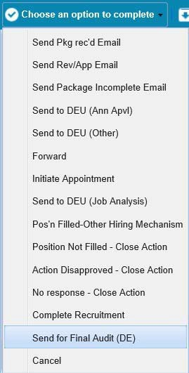

**Tip:** Sending the Recruitment to the DEU for Final Audit does not close the Recruitment action, but completes the process for the Branch.

### Complete Recruitment

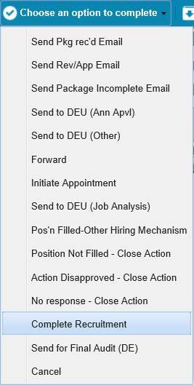For non-DEU recruitment actions: Select this option when all of the certificates have expired, all Hiring Decisions (i.e., selections or non-selections) have been returned by the Selecting Official(s) (to include any shared certificates), and the action has been accurately updated, specifically the Certificate Information tab.

An email notification is sent to the HR Specialist notifying them that the action has been completed.

**NOTE:** Even after a Recruitment action has been closed, related Appointment actions can still be initiated and linked to the recruitment by entering the Recruitment Number.

### No Response – Close Action

Select this option when you (the Branch HR Specialist) have received no communication or follow-up on the recruitment action for 90 consecutive days during the pre-recruitment phase of the action. Please consult your Team Leader or Branch Chief before using this option. This will close (not cancel) the action and send it to Archives.

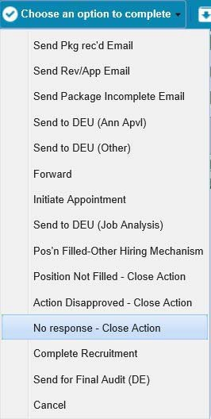

An email is sent to the AO, Selecting Official, and Supervisor advising them that the action was closed due to no response, and that the action is being closed.

## Appendix 1: Reminder Emails

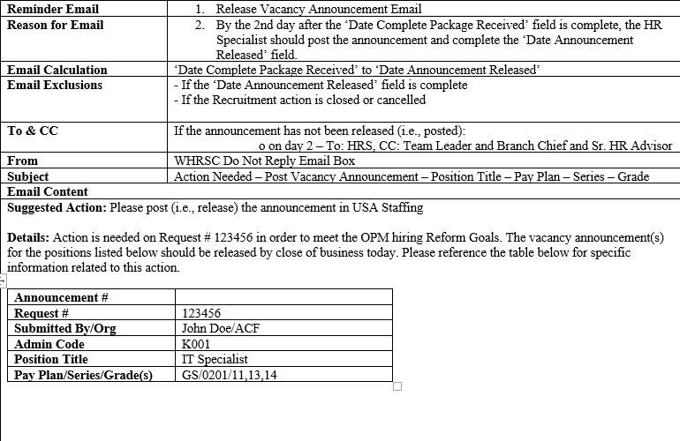

### Post Vacancy Announcement Email

### Issue Certificate (DEU) Email

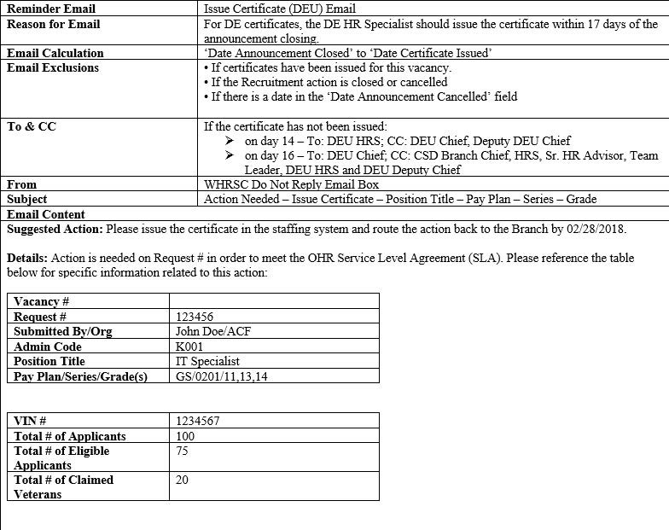

### Issue Certificate (DEU) SLA Exceed Email

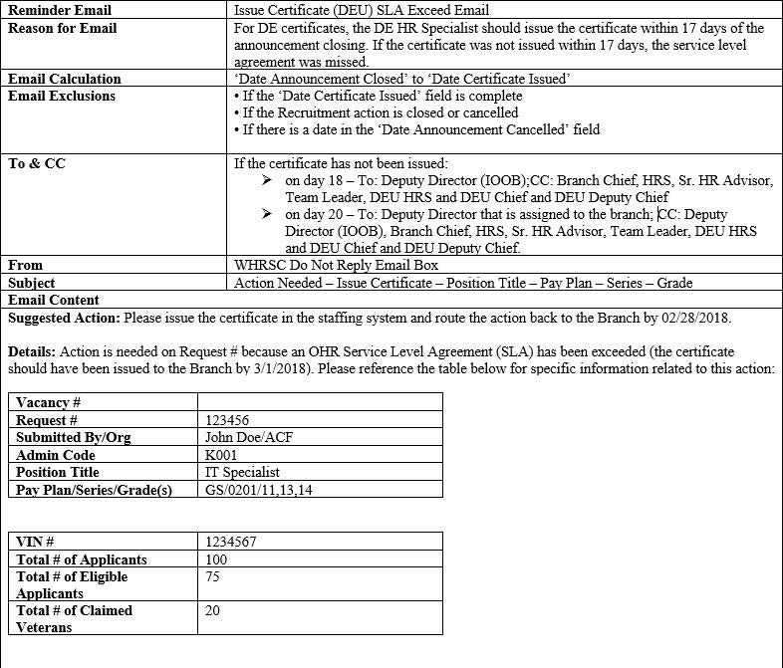

### Send Certificate (DEU) to Selecting Official Email

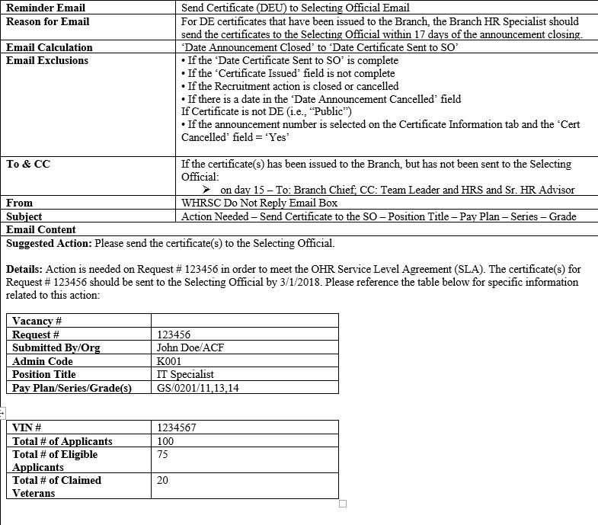

### Send Certificate (DEU) to Selecting Official SLA Exceed Email

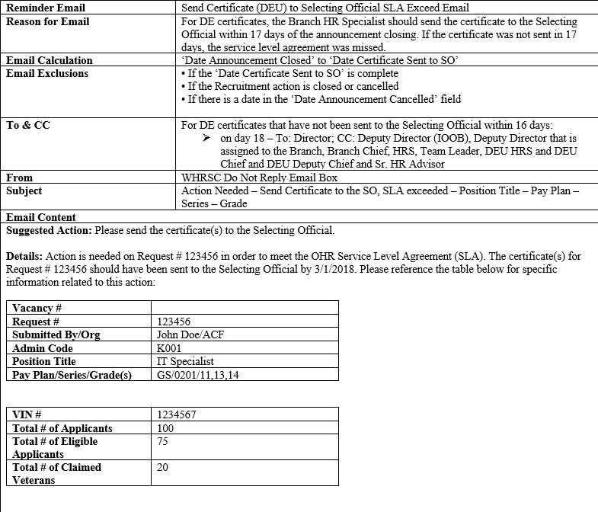

### Send Certificate (MP or DH) to Selecting Official Email

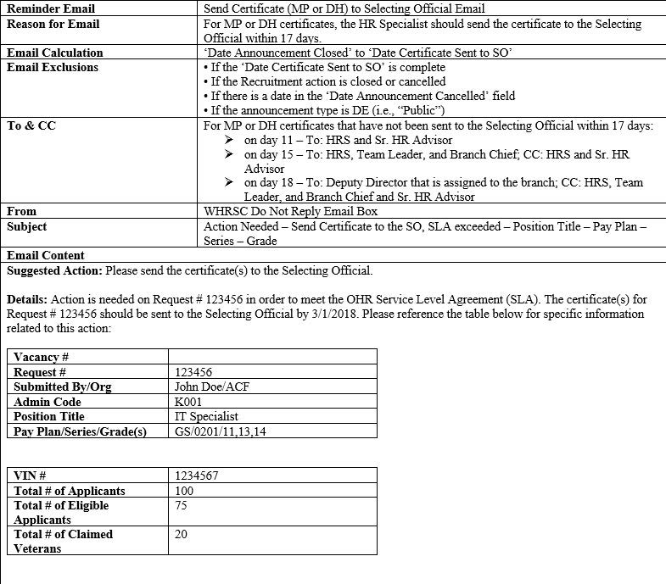

### Certificate Expiration Email (HRS)

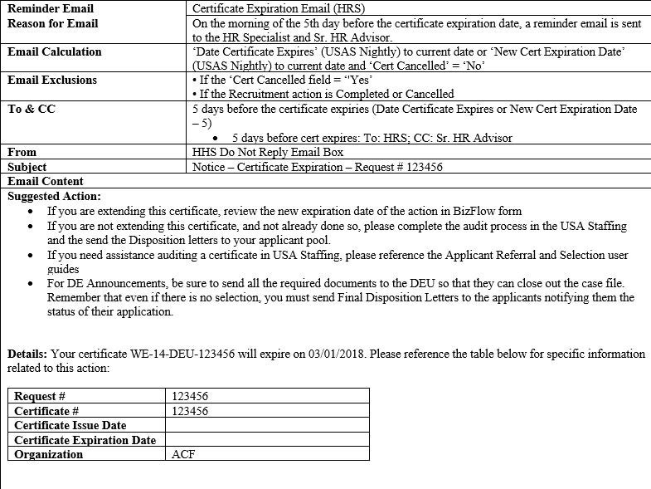

### Certificate Expiration Email (Customer)

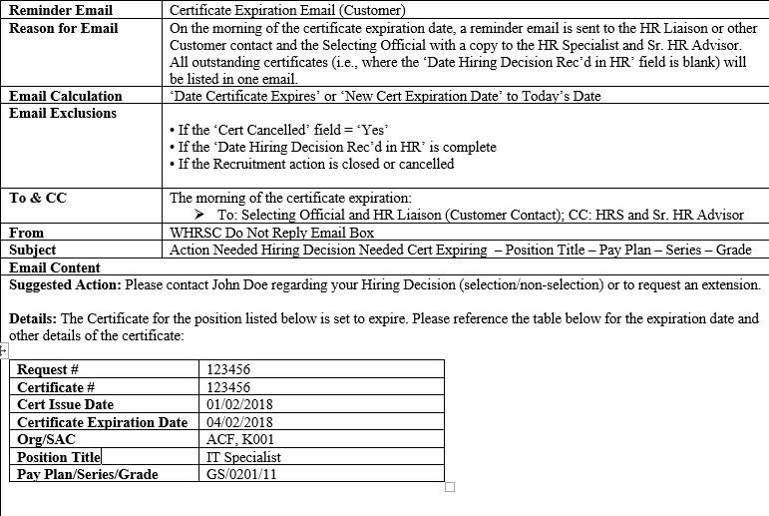

### Hiring Decision Needed Email

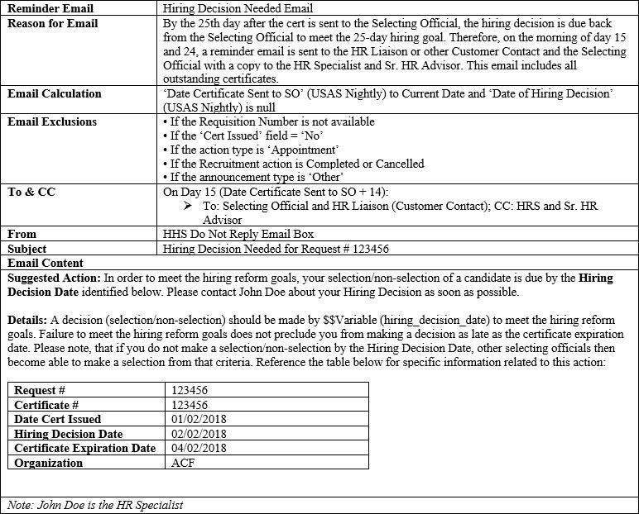

### Feedback Requested Email

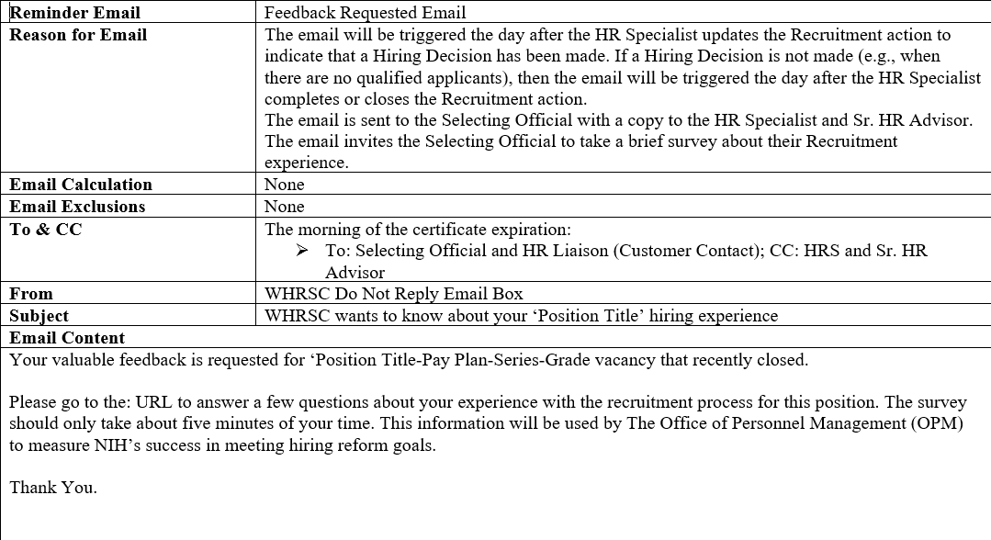

### Unaudited Certificate Email

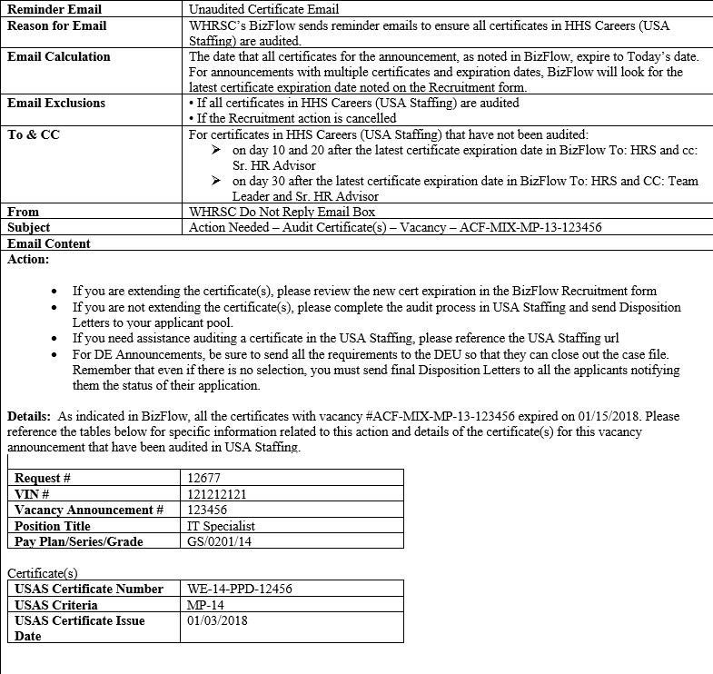

**Appendix 2: Recruitment Workflow**

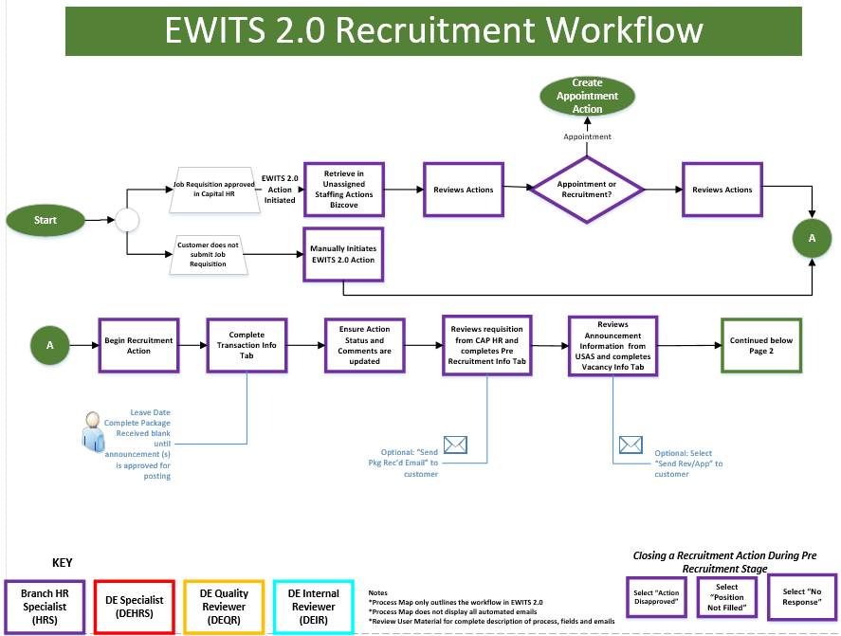

**Appendix 2: Recruitment Workflow**

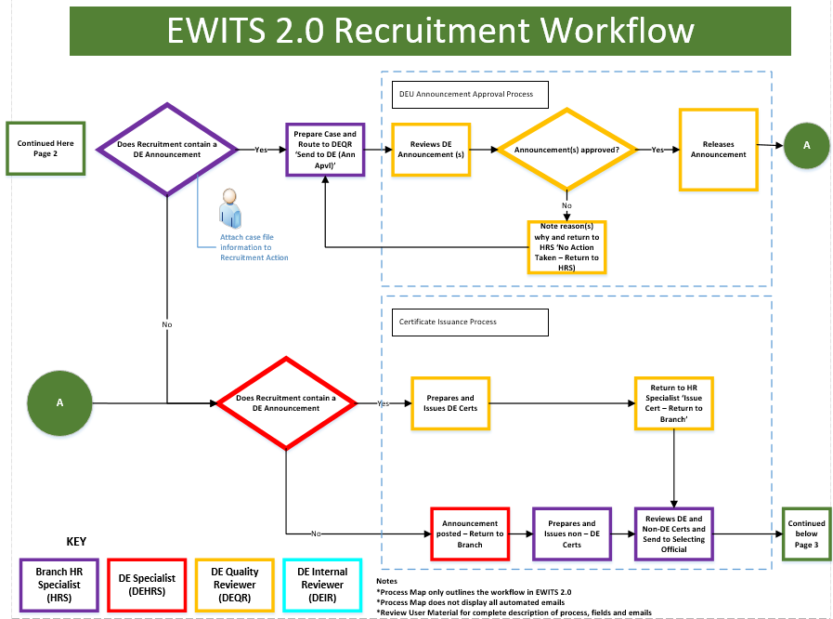

**Appendix 2: Recruitment Workflow**

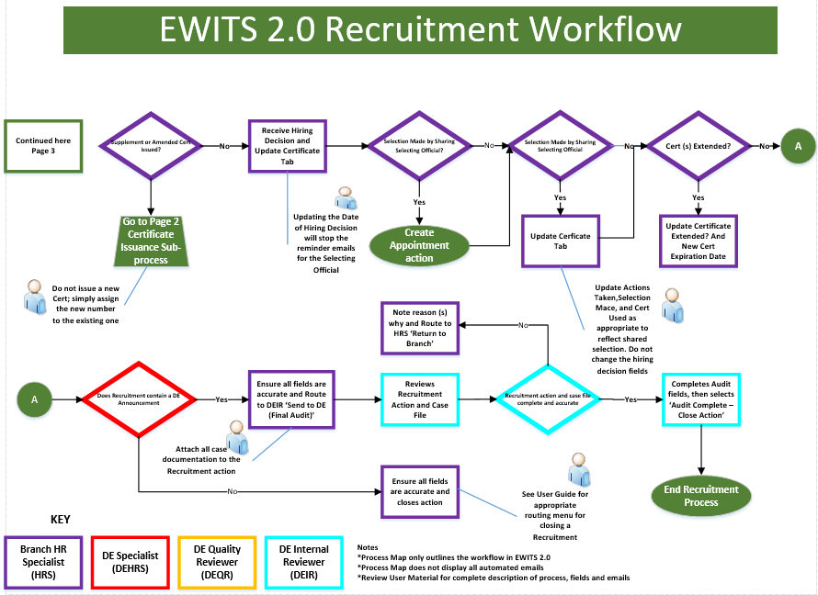

**Appendix 3: Routing Options**

The Routing Options drop down menu presents users with quick "Jump To" functions that will assist them in completing, initiating follow up and keeping their work items up to date.

### Send Pkg rec'd Email

Select this option to communicate when a recruitment action has been received.

### Send Rev/App Email

Select this option to communicate when items related to the vacancy announcement are ready for review.

### Send Package Incomplete Email

Select this option to communicate that items related to the vacancy announcement are not ready for review.

### Send to DEU (Ann Apvl)

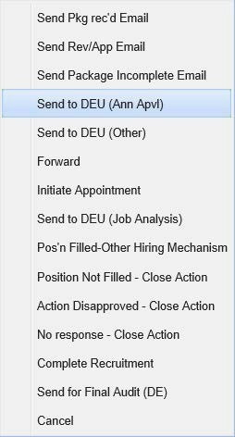

Select this option to communicate when a vacancy announcement is ready for the DEU to review and approve.

### Send to DEU (Other)

Select this option to communicate when the action needs to be sent to DEU for any other approvals.

### Forward

Select this option to communicate when the action needs to be assigned to another HR Specialist.

### Initiate Appointment

After all of the tabs on the Recruitment form have been completed, you can select this option to initiate an Appointment action.

### Send to DEU (Job Analysis)

Select this option to communicate when the action is sent to DEU for Job Analysis.

### Pos'n Filled-Other Hiring Mechanism

Select this option to communicate when the current position has been filled using an alternative hiring mechanism.

### Position Not Filled - Close Action

Select this option to communicate when the position has not been filled and the option can be closed.

### Action Disapproved - Close Action

Select this option to communicate when the action has been disapproved and can be closed.

### No response - Close Action

Select this option to communicate when you have received no communication or follow-up on the recruitment action for 90 consecutive days during the pre-recruitment phase of the action.

### Complete Recruitment

Select this option to communicate when all of the certificates have expired, all hiring decisions have been returned by the selecting official(s), and the action has been accurately updated.

### Send for Final Audit (DE)

Select this option to communicate when the action is ready for final audit by the DEU.

### Cancel

Select this option to communicate when the action can be cancelled.